

Department of Computer Science

MY University, Islamabad.

**Implementation Phase (LAB)**

**Project No: 05**

**Course Title: Database System**

**Student Name: Taha Saddiqui**

**Registration No: baib232005**

**Batch: Fall2023**

**Program: Ai**

**Semester: 6th**

**Lab Instructor: Mr. Hamza Javed**

**Submission Date: 27/04/24**



**Department of ComputerScience**

**Spring-2024 DataBase Systems (CS-103)**

Lab Task # 05

# SQL-SELECT, Arithmetic Operation, Comparison Operator

*Instructors: Mr. Hamza Javed Date: 29 April 2023*

**Important Instruction**

1. No plagiarism allowed.
2. You will required to submit only soft copy via google classroom
3. Late submission not accepted
4. Rename submission file DB24-Name-RegNo. **like: DB24-hamza-1234**
5. You will required to submit single **pdf**

**Submission Example**

**Question .**

Write query to select all data from table:

**Solution**

SELECT * FROM db.detail;

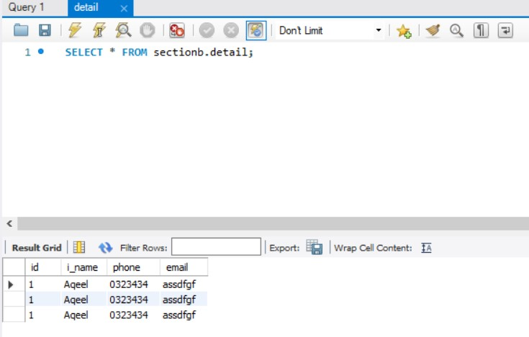

**Question 1**

Write SQL query based on given table:

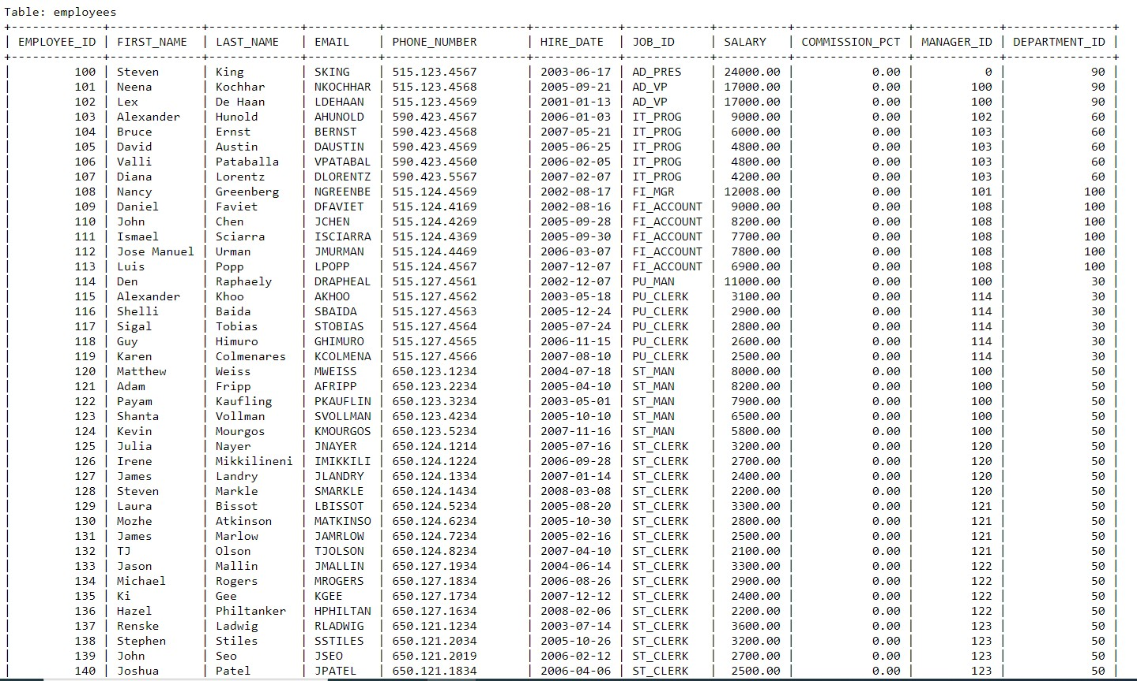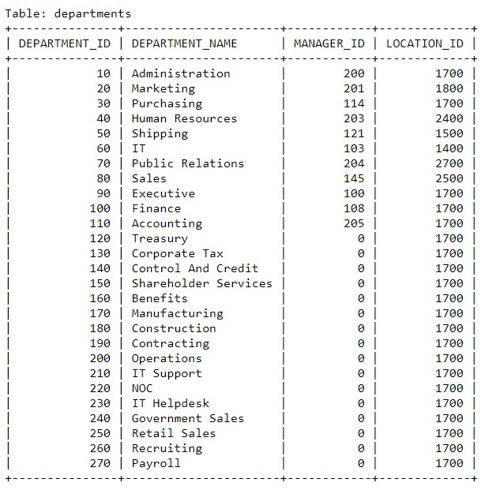

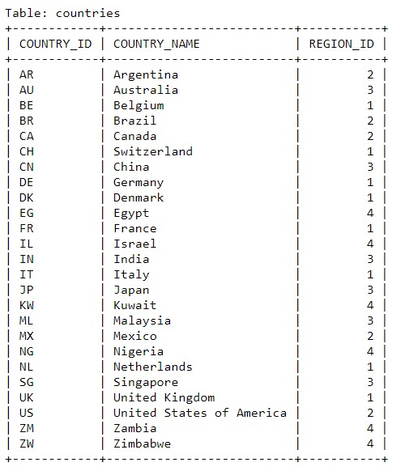

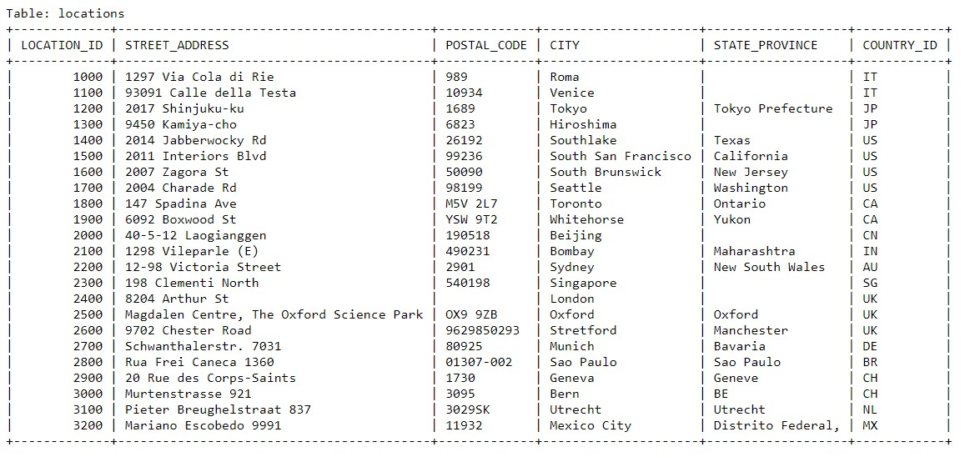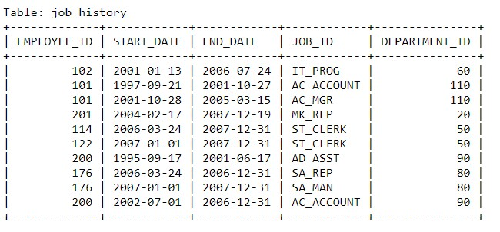

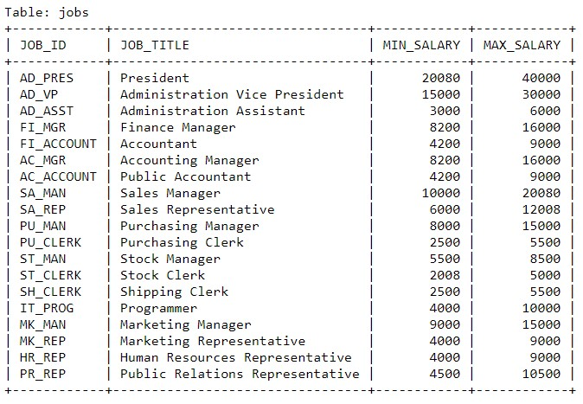

**Write a query to display employee_id, name and salary, department of all employees also display increased salary by 2000.**

SELECT

Employee_ID,

CONCAT(First_Name, ' ', Last_Name) AS Employee_Name,

Salary AS Original_Salary,

(Salary + 2000) AS Increased_Salary

FROM

employees;

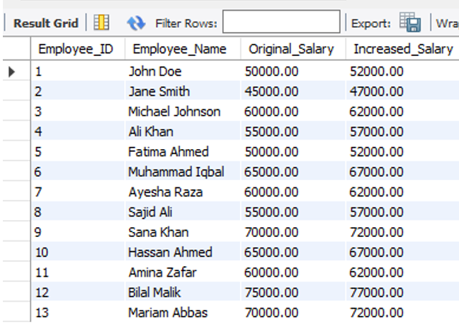

**Write a query to display employee id, name and salary, department of all employees also display increased salary by 5 %.**

SELECT

Employee_ID,

CONCAT(First_Name, ' ', Last_Name) AS Employee_Name,

Salary AS Original_Salary,

(Salary + (Salary * 0.05)) AS Increased_Salary FROM

employees;

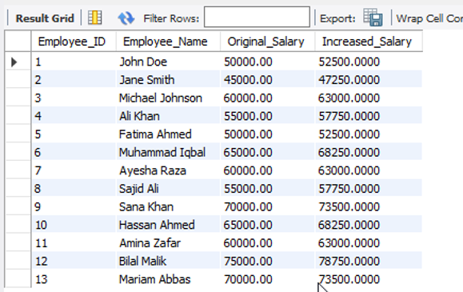

**Write a query to display employee id, frst name, salary of those employee whose job id is IT Prog.**

SELECT

Employee_ID, First_Name,

Salary

FROM

employees WHERE

Job_ID = 'IT_PROG';

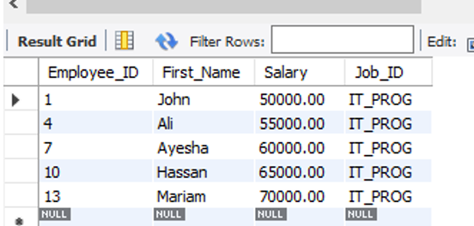

**Write a query to display employee id, frst name, salary, department id of those employee who working as IT_Prog and salary not equal to 20000.**

SELECT

Employee_ID,

First_Name, Salary, Department_ID

FROM

employees WHERE

Job_ID = 'IT_PROG'

AND Salary != 20000;

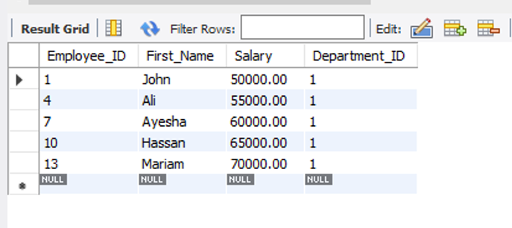

**Write a query to display all records of those employee who job id 125 or salary equal to 3200.**

SELECT

*

FROM

employees WHERE

Job_ID = '125' OR Salary = 3200;

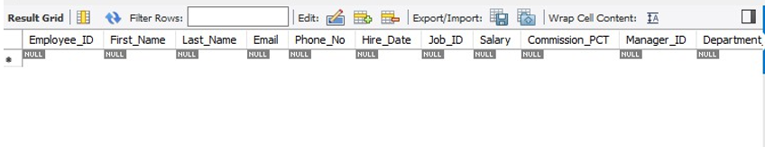

**Write a query to display all records of those employee who joining date is 20 June 1999 to 25 Aug 2001.**

SELECT

*

FROM

employees WHERE

JOIN_DATE BETWEEN '1999-06-20' AND '2001-08-25';

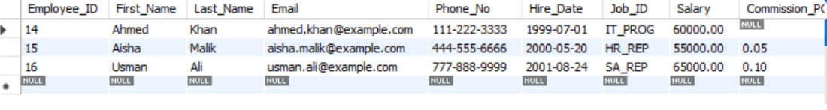

**Write a query to display employee id, email, salary, job id of those employee who working as faculty and clerk and salary greater than equal to 12000.**

SELECT

Employee_ID, Email,

Salary, Job_ID

FROM

employees WHERE

(Job_ID = 'FACULTY' OR Job_ID = 'CLERK')

AND Salary >= 12000;

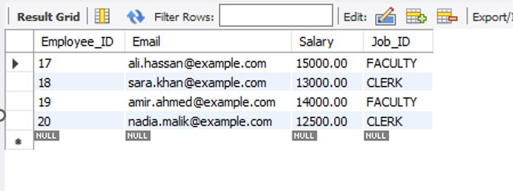

**Write a query to display all records of those employee who working as programmer and analyst and department 10 and 20 and hire date from 20-Aug-2018 to 19- AUG- 2021.**

SELECT

*

FROM

employees WHERE

(Job_ID = 'PROGRAMMER' OR Job_ID = 'ANALYST')

AND (Department_ID = 10 OR Department_ID = 20)

AND Hire_Date BETWEEN '2018-08-20' AND '2021-08-19';

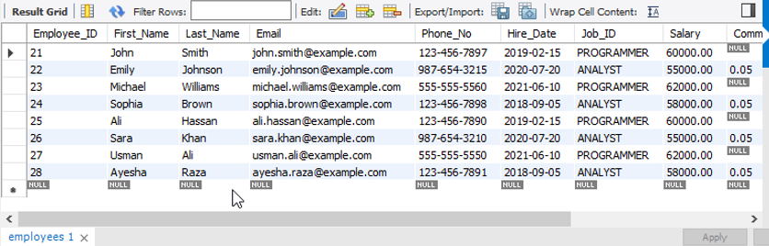

**Write a query to display all records of those employee whose first name started from A character.**

SELECT

*

FROM

employees WHERE

First_Name LIKE 'A%';

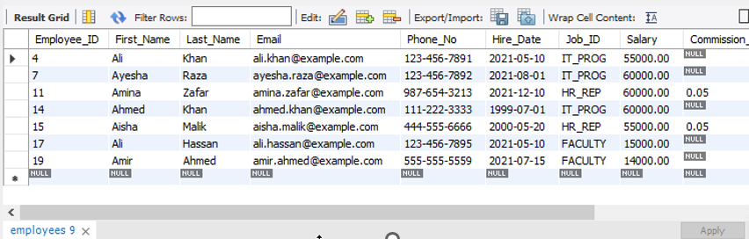

**Write a query in SQL to display the first name and last name, department id and salary from employees Table who earn more than 20000.**

SELECT

First_Name, Last_Name, Department_ID, Salary

FROM

employees WHERE

Salary > 20000;

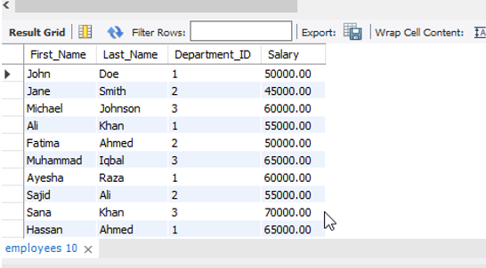

**Write a query in SQL to display the first name and last name, email, salary and manager ID for those employees whose managers ID is 120, 103 or 145.**

SELECT

First_Name, Last_Name, Email,

Salary, Manager_ID

FROM

employees WHERE

Manager_ID IN (120, 103, 145);

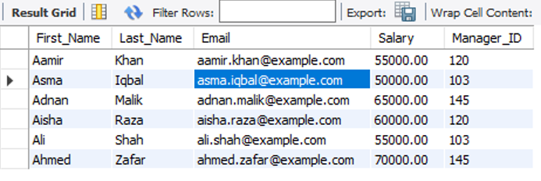

**Write a query in SQL to display the first name and last name,department id and salary from employees Table who earn more than 8000 And whose managers ID is 120, 103 or 145.**

SELECT

First_Name, Last_Name, Department_ID, Salary

FROM

employees WHERE

Salary > 8000

AND Manager_ID IN (120, 103, 145);

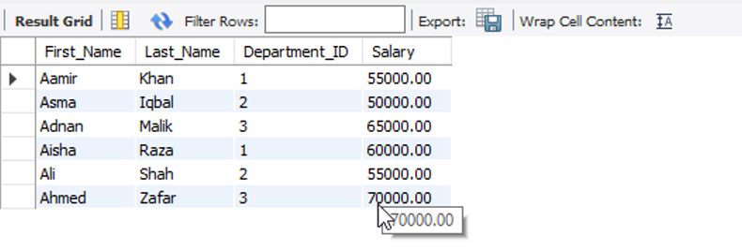

**Write a query to display all records of those employee whose first name last character is r.**

SELECT

*

FROM

employees WHERE

First_Name LIKE '%r';

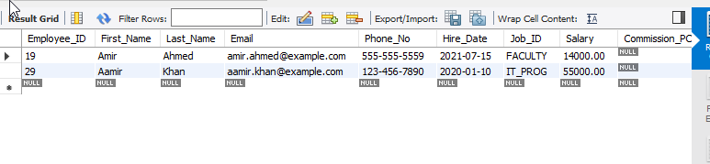

**Write a query to display all records of those employee whose first name second character is a and last name second last character is i.**

SELECT

*

FROM

employees WHERE

First_Name LIKE '_a%'

AND Last_Name LIKE '%i_';

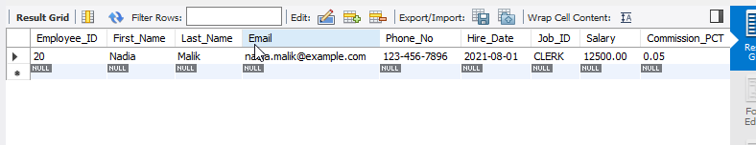

**Write a query to display employee id, first name as name and salary increased by 10 % as Increased salary of those employee whose first name third last character is p and getting salary 10000, 20000 and 30000.**

SELECT

Employee_ID, First_Name AS Name,

Salary * 1.10 AS Increased_Salary FROM

employees WHERE

First_Name LIKE '%p %'

AND Salary IN (10000, 20000, 30000);

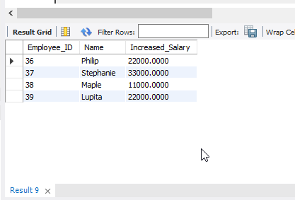

**Write a query to display all records of those employee whose first name not started with A letter and salary is not mentioned.**

SELECT

*

FROM

employees WHERE

First_Name NOT LIKE 'A%'

AND Salary IS NULL;

**Write a query to display employee id,first name and salary in descending order using salary column.**

SELECT

Employee_ID, First_Name,

Salary

FROM

Employees

ORDER BY

Salary DESC;

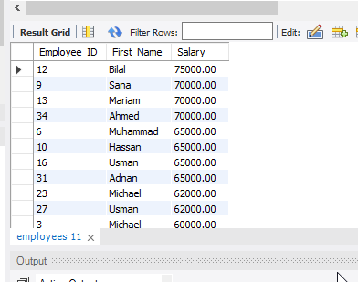

**Write a query to display all the locations (id, city) which do not have any state province mentioned.**

SELECT

Location_ID,

City

FROM

Location

WHERE

State_Province IS NULL;

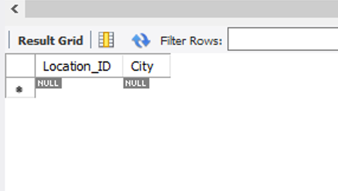

**Write a query to display the job title whose minimum salary is greater than 8000 and max salary less than 20000.**

SELECT

Job_Title FROM

jobs WHERE

Min_Salary > 8000

AND Max_Salary < 20000;

